**Writeup for phase-2 projects:**

**Question:**

**Kitchen Story**is an e-commerce portal that lets people shop basic food items on their website. The website needs to have the following features:

* A search form in the home page to allow entry of the food items to be purchased by the customer.
* Based on item details entered, it will show available food items with price.
* Once a person selects an item to purchase, they will be redirected to the list of available items. In the next page, they are shown the complete breakout of the order and details of the payment to be made in the payment gateway. When payment is done, they are shown a confirmation page with details of the order.

For the above features to work, there will be an admin backend with the following features:

* Admin login page where admin can change password after login if he wants to
* A master list of food items available for purchase
* A functionality to add or remove food items

**To run the code, please type**

* **Ng serve --o**
* **Npm start**

**In two separate terminals. Ng serve will run the angular code and open the code in a browser.**

**Whereas, npm start will start the local json server, to read the data in the json file.**

* Explanation via images:

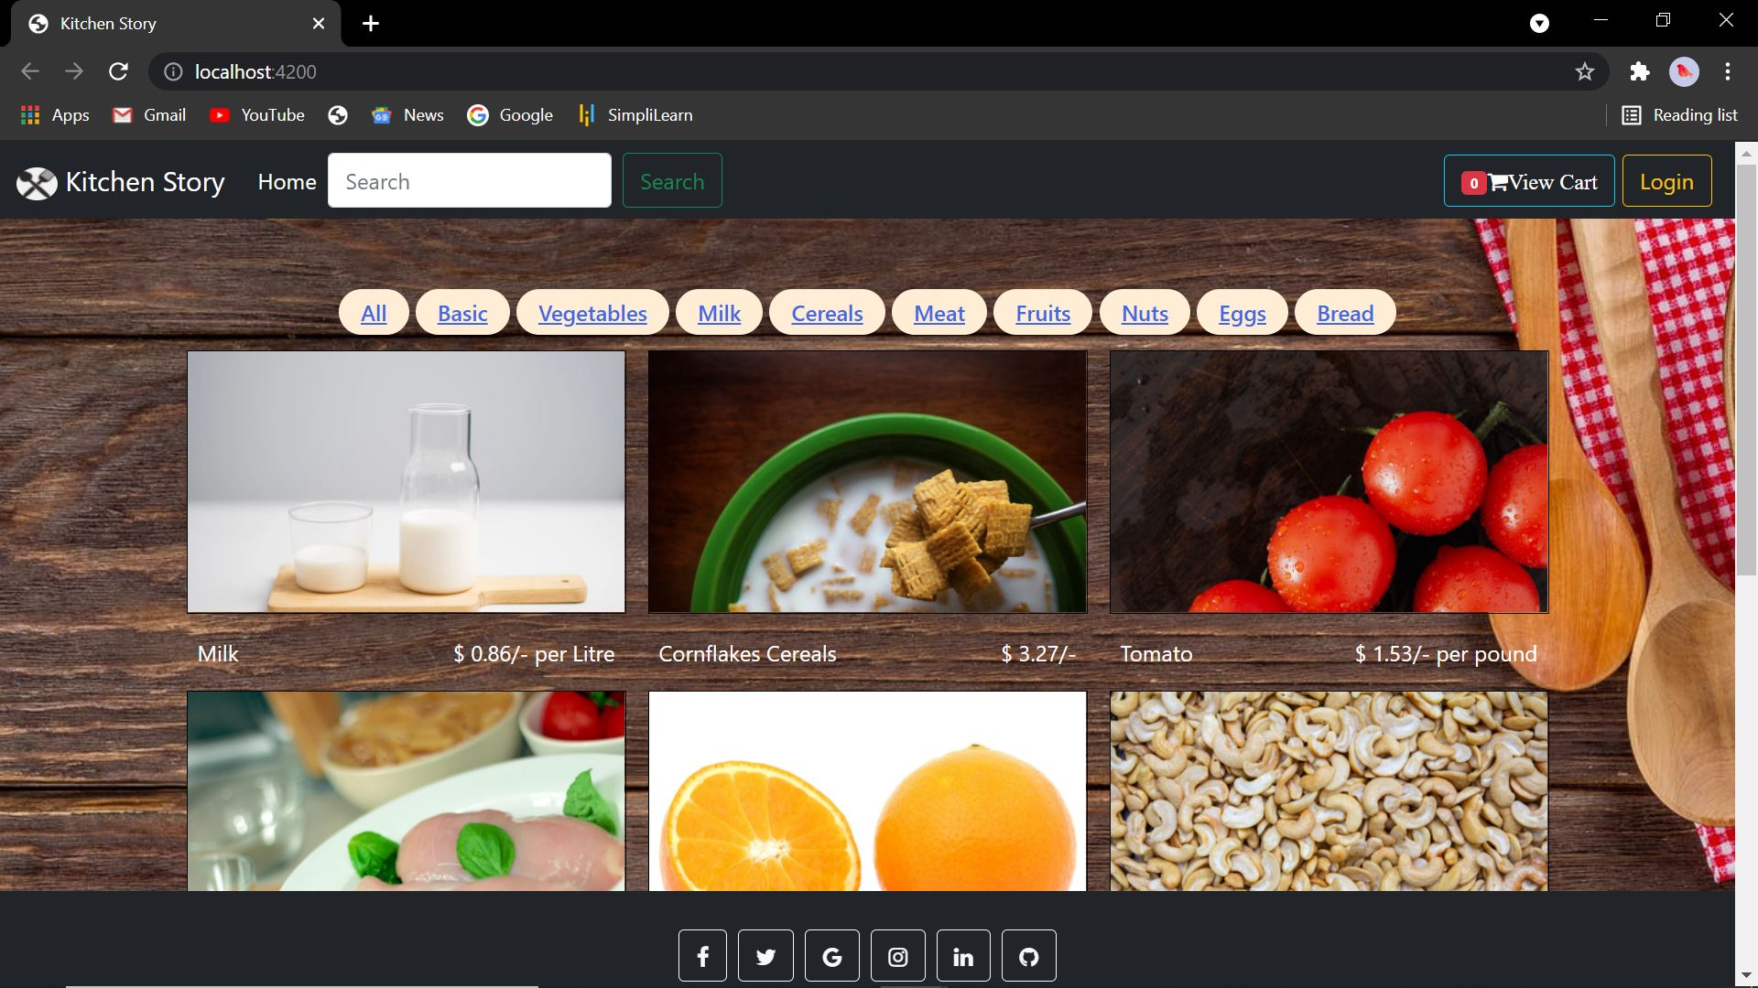

**Fig 1: Home page (part-1)**

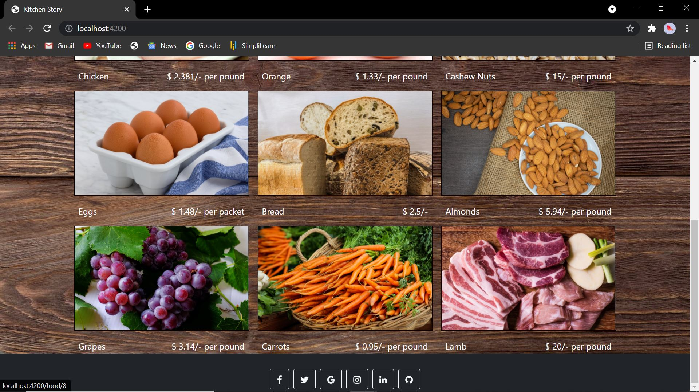

**Fig 2: Home page_2 (part-2)**

* **Fig 1** and **Fig 2** are the images of the homepage created for the website of name ‘**Kitchen Story**’.
* The homepage contains a navbar (header component) which consists of:
  + the navbar brand ‘Kitchen Story’ with the logo,
  + the home tab which when clicked on, takes you to the home page.
  + The search bar, for the user to type and search for individual items.
  + The ‘view cart’ button, which when clicked on, will take the user to the cart page containing the selected items and their price.
  + The login button for the user to login to their respective account, which will change to logout, once the user/admin logs in.
* The homepage contains the tags of selective words, which when clicked on will display the items related to that word. For example: when clicked on the ‘meat’ tag, the images of both chicken and lamb will be shown.
* The homepage contains the product details in the form of a grid.
* The product details contains the id,name,image url,price,tags and per price value. The data is taken from db.json in **fig 7** which is running in live json server in port:3000. “http://localhost:3000/posts”
* The homepage also contains a footer that contains the several social media buttons.
* The homepage is also responsive. As in, the mobile view, it changes the dimensions accordingly and displays the page as per the screen size.
* The page is the default page that loads when the user first sees the site.
* The code for this page is in the ‘home-component’, which contains the body of the site. In the ‘header-component’, the code contains the navbar of the site. In the ‘footer-component’, the code contains the footer of the site.
* Both the ‘header-component’ and ‘footer-component’ are common for all the pages.
* The images are represented in the form of a grid, along with their details.
* If the user clicks on any image, they’ll be taken to the page as seen in **Fig 6.3**, where they can add the selected item to the cart.

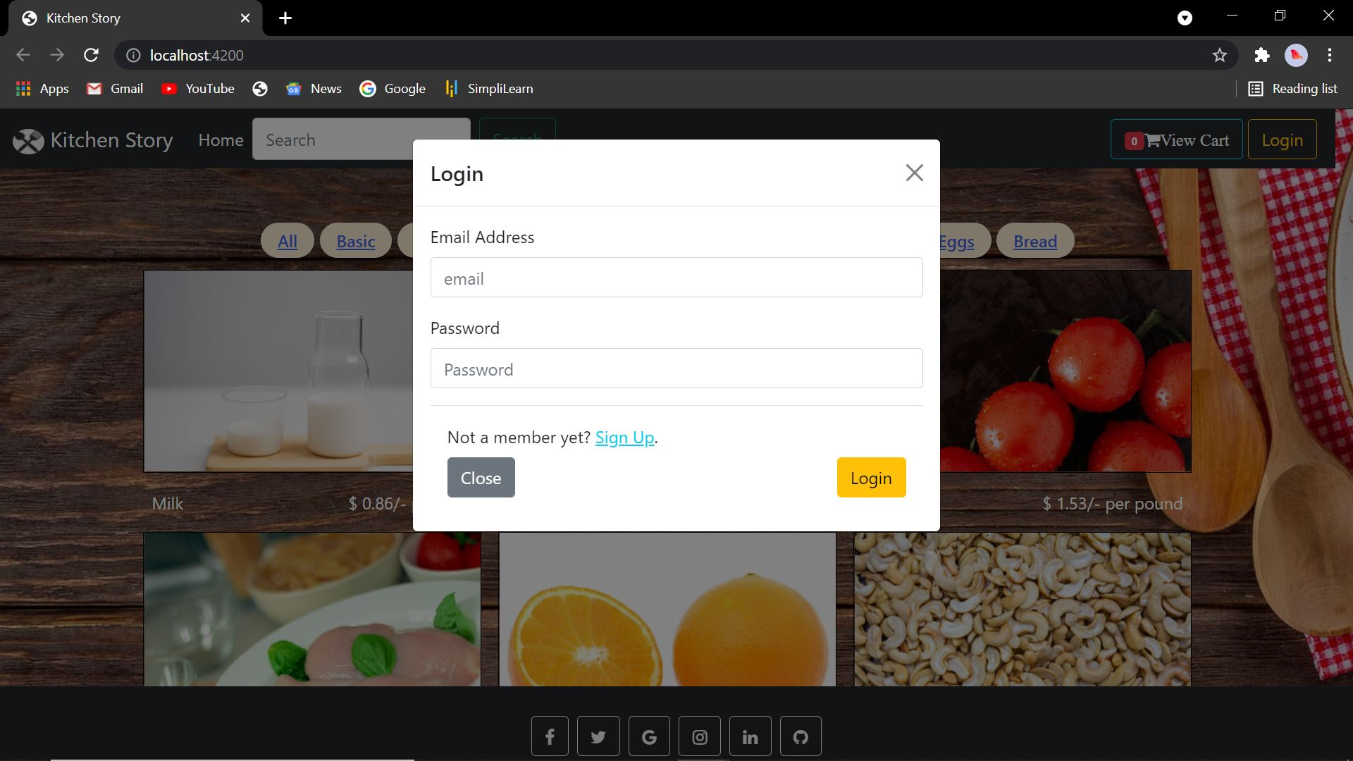

**Fig 3: Login Modal**

* The login modal opens, when the user clicks on the login button.
* The modal consists of two input boxes: ‘Email Address’ with the placeholder as ‘email’ and ‘Password’ with the placeholder as ‘Password’.
* Contains two buttons, close and login.
* When the user enters the values, the code will check if the admin has added the details in the db.json file in the users object. If it matches, ‘Login Successful’ will popup. Else, “Invalid details!” will popup.
* If a new user, wants to create an account, they can click on the highlighted “Sign Up”, which will then direct them to a sign-up modal, where they have to fill up their details as seen in **fig 4**.
* For both the login as well as signup modals, the form will automatically reset itself, if, the “Invalid Details!” popup.

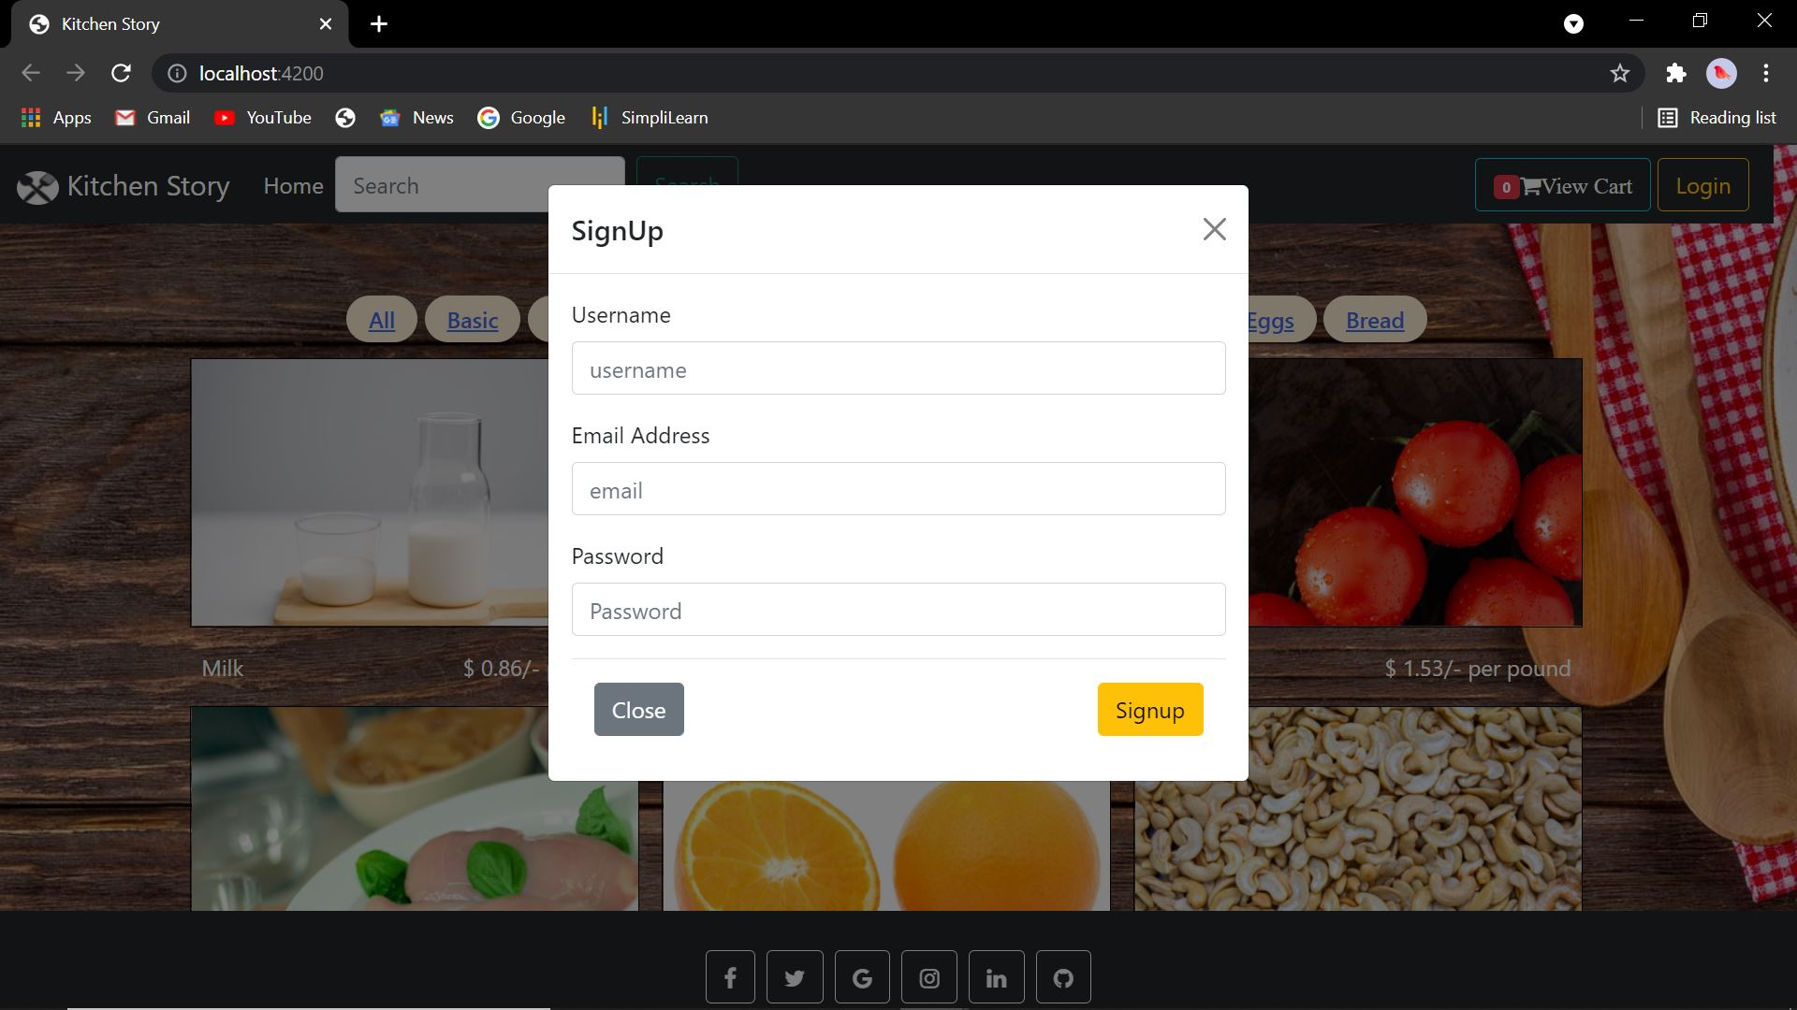 **Fig 4: Signup Modal**

* The signup Modal consists of the username, email address and password to be entered by the user. After clicking on the signup button, the details are stored in “users” object in the db.json file, which can then be viewed in the admin login dashboard.

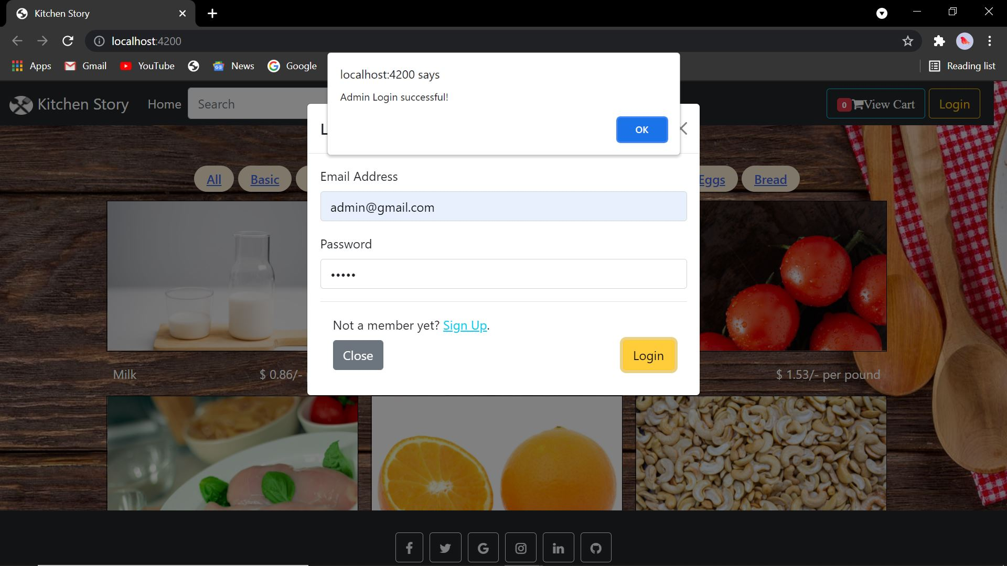

**Fig 5: Admin Login.**

* The admin, will enter his respective details which is:

Email Address: [admin@gmail.com](mailto:admin@gmail.com)

Password:admin.

* Once validated, the admin, will be taken to the admin page, that can only be accessed by the admin and not the users.

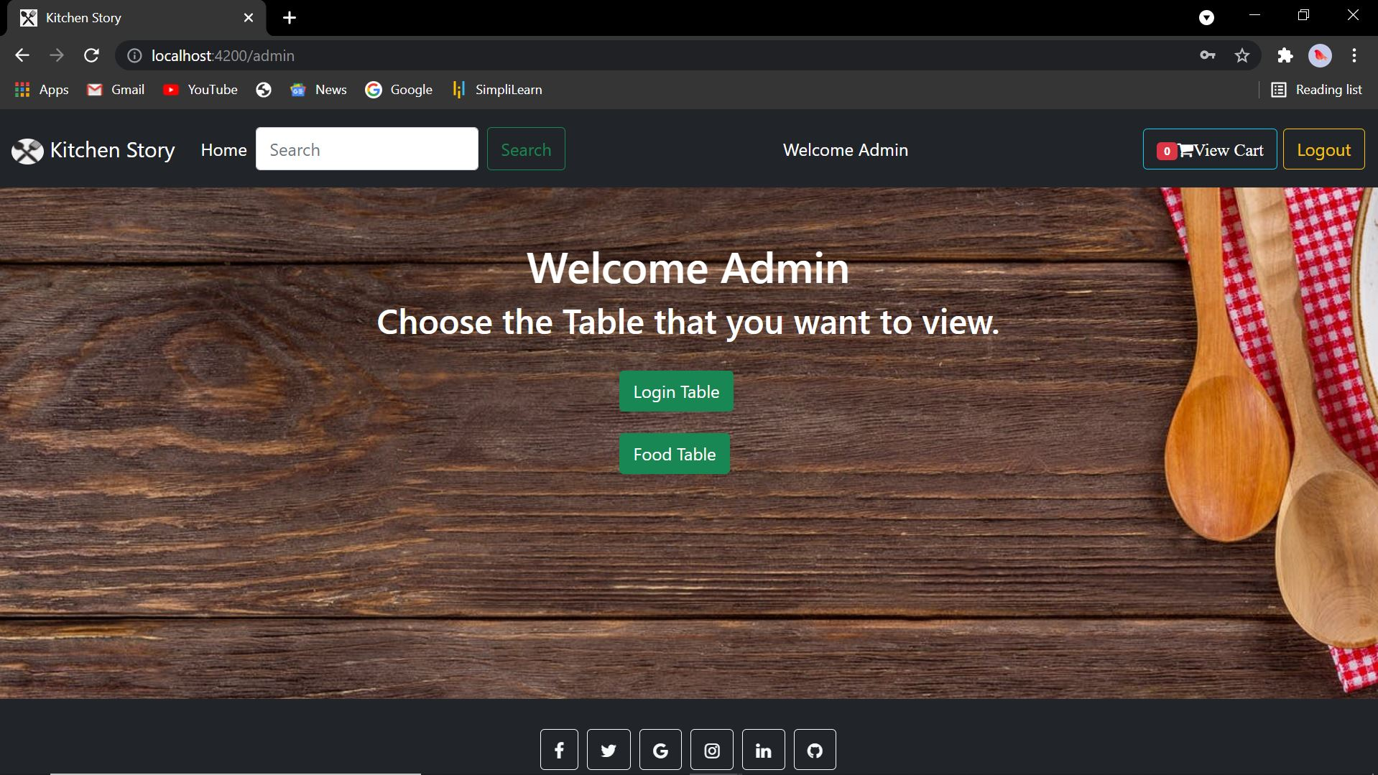**Fig 5.1: Admin Main Page.**

* The admin main page contains two buttons, login and Food table, which when clicked on, will take the admin to the respective dashboard.
* As noticed, when the admin logs in, In the navbar, the following changes are noted in the navbar.
* The “Welcome Admin” will be displayed.
* The login button changes to logout.

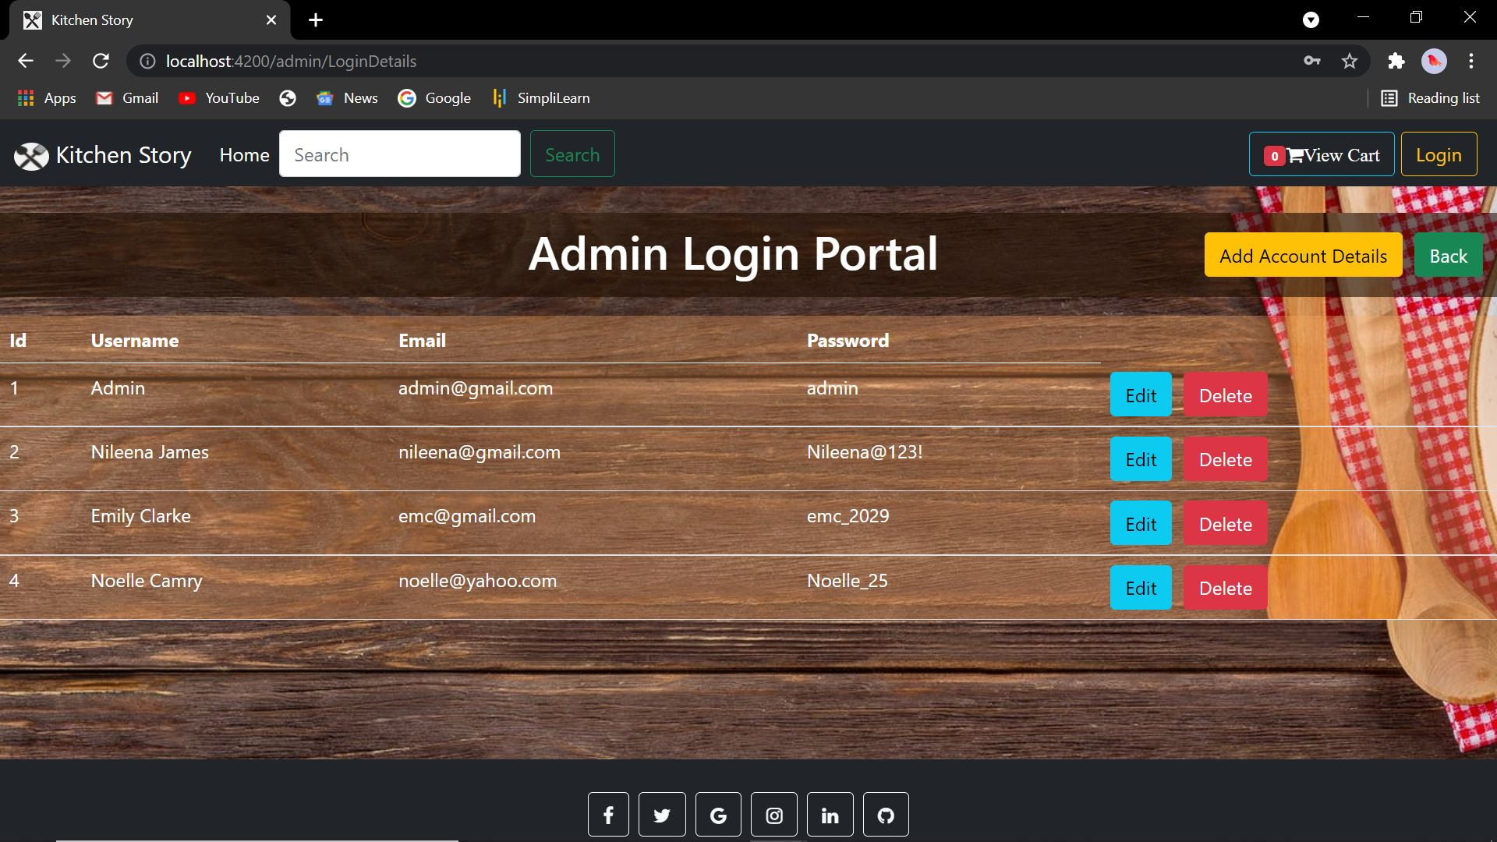 **Fig 5.2: Admin Login Dashboard. 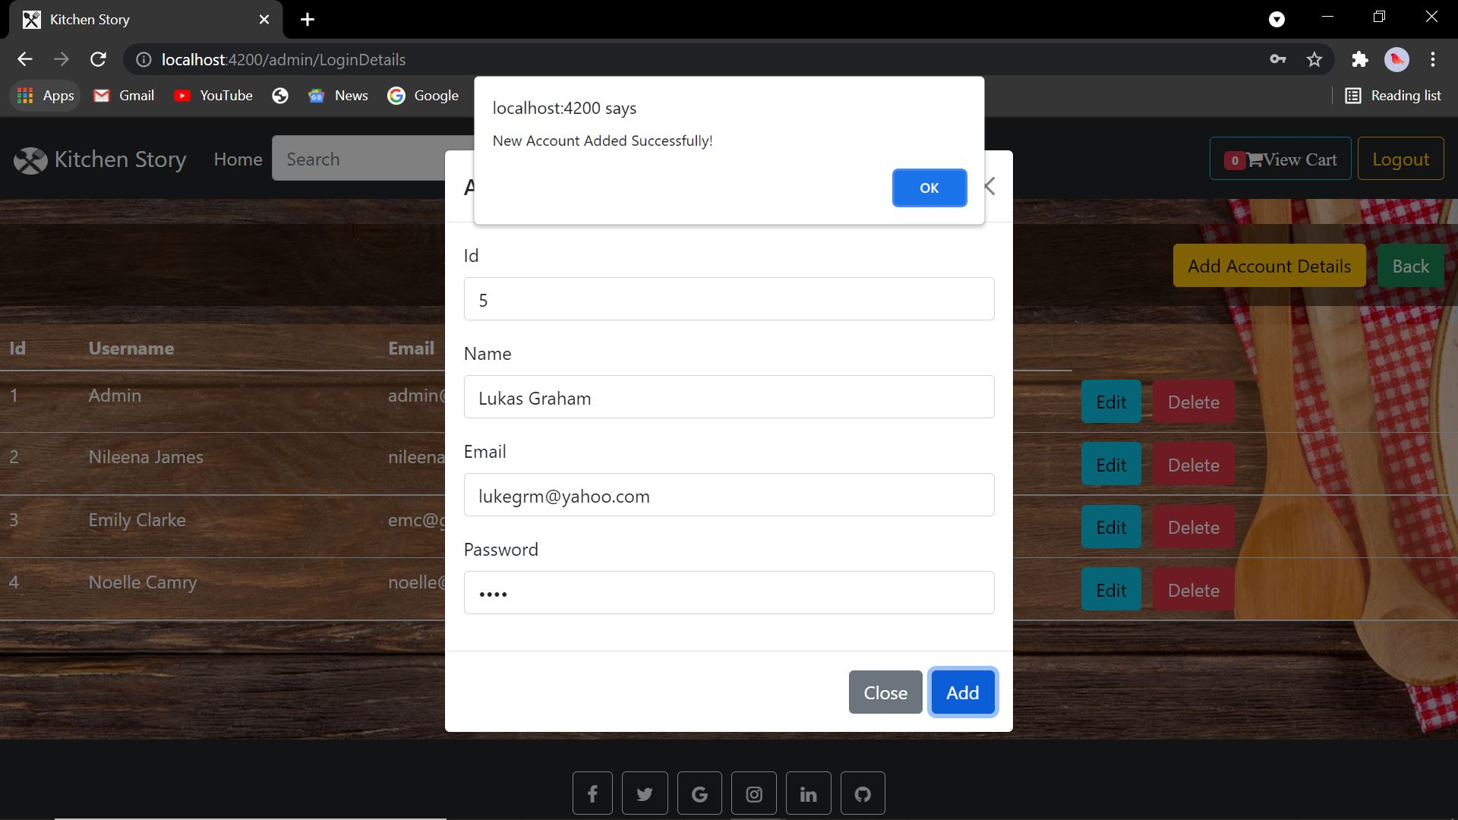 Fig 5.3: Adding new user account (Lukas Graham). 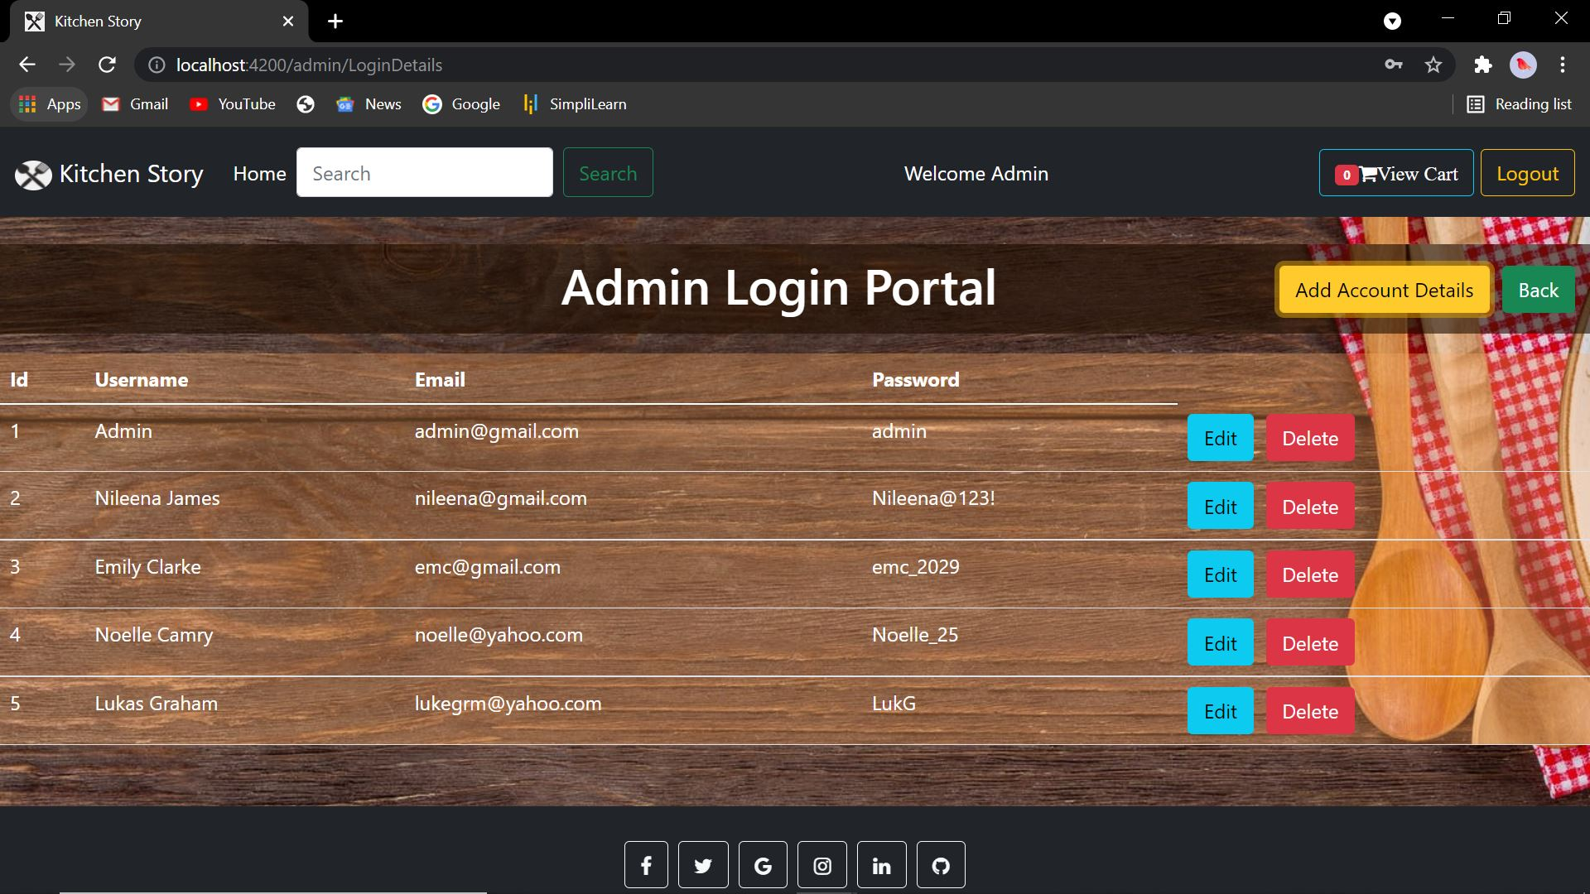 Fig 5.4: Updated table after adding new account. 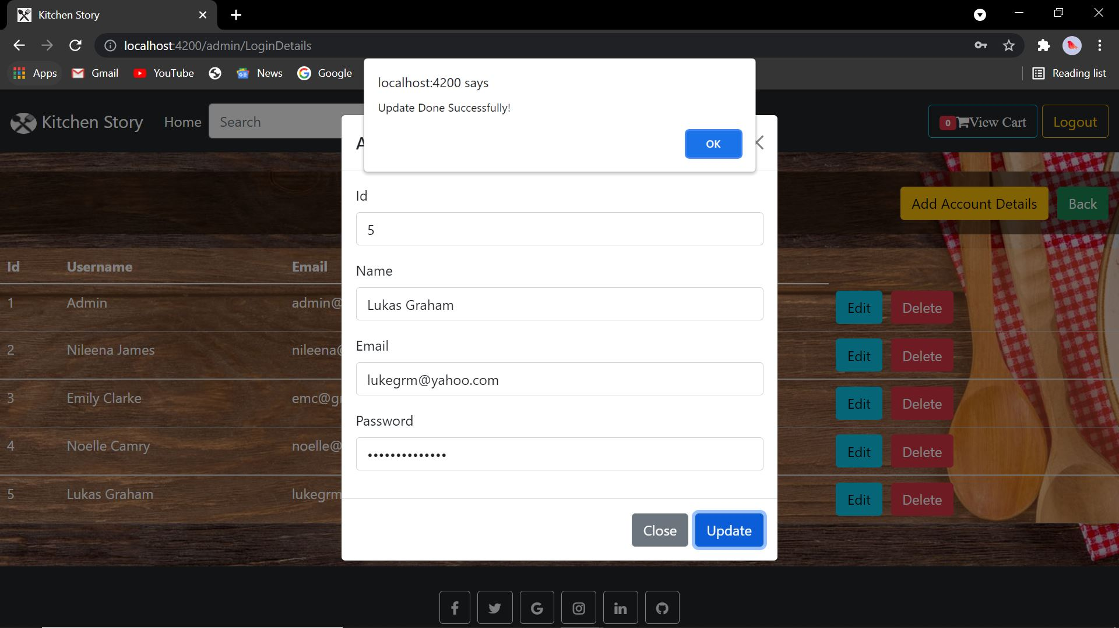 Fig 5.5: Updating the Lukas’s password. 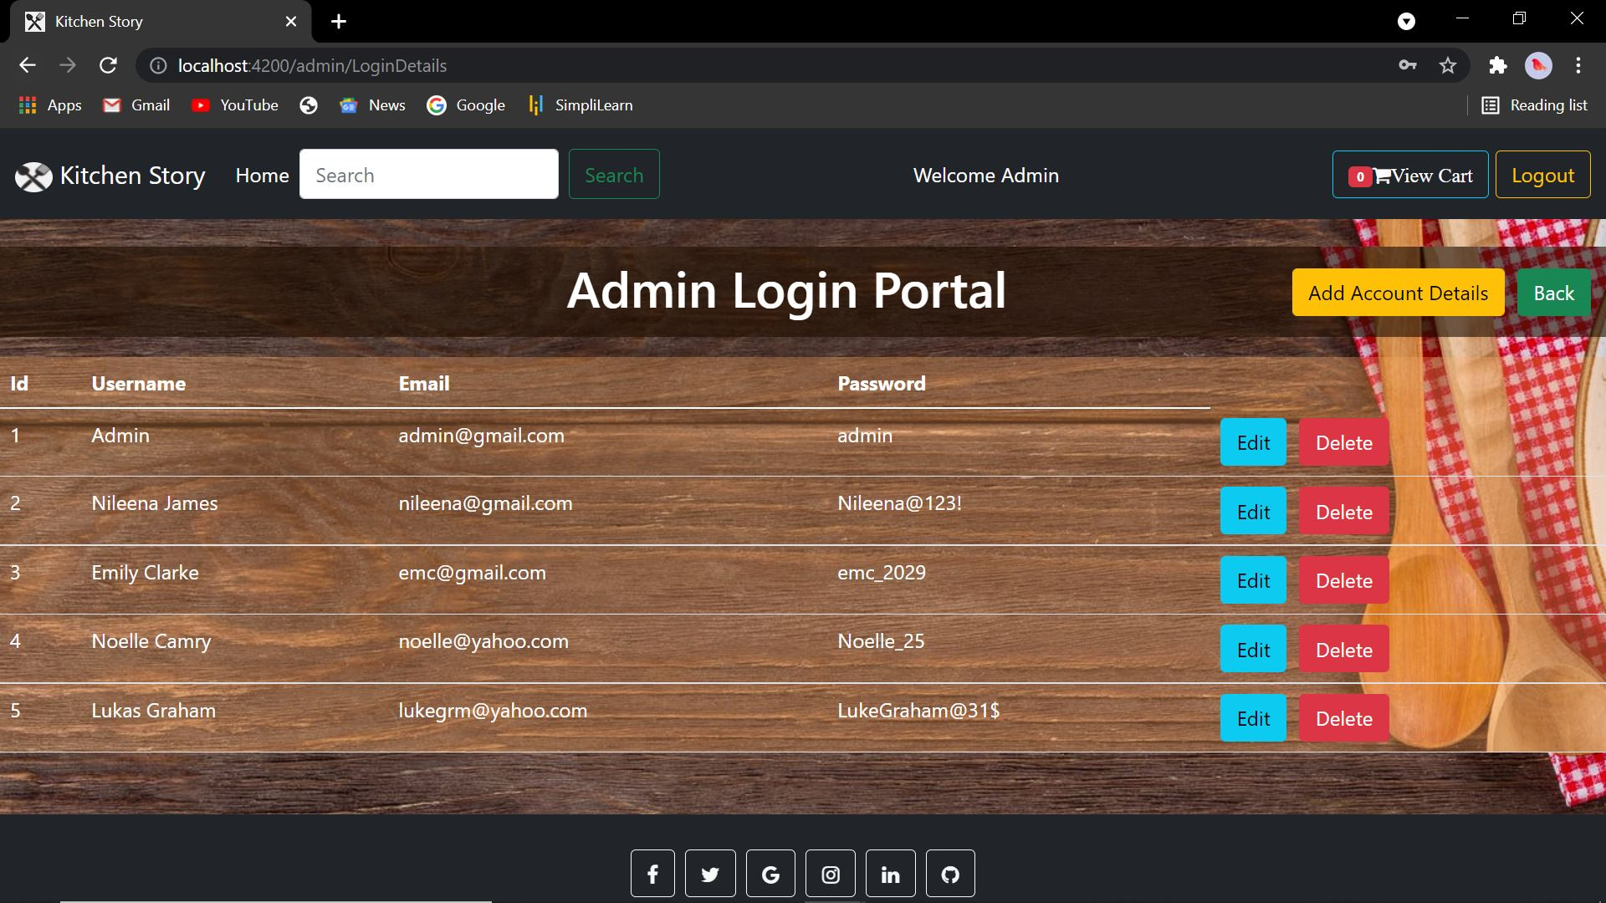 Fig 5.6: Updated table with new password. 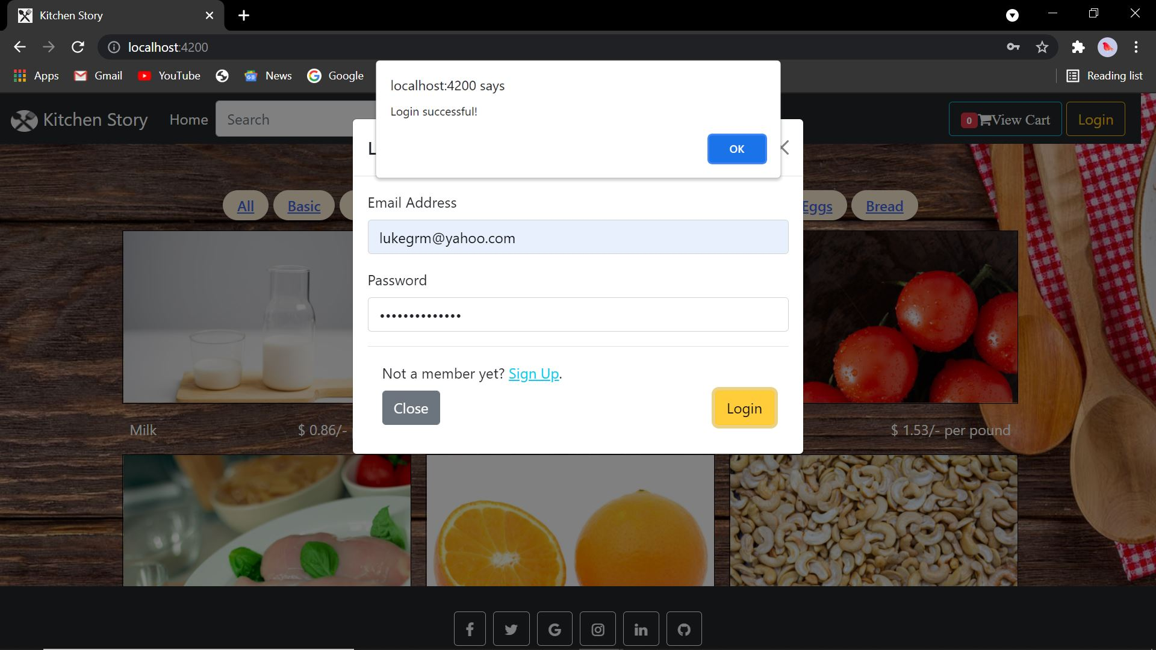 Fig 5.7: Login using lukas’s account. 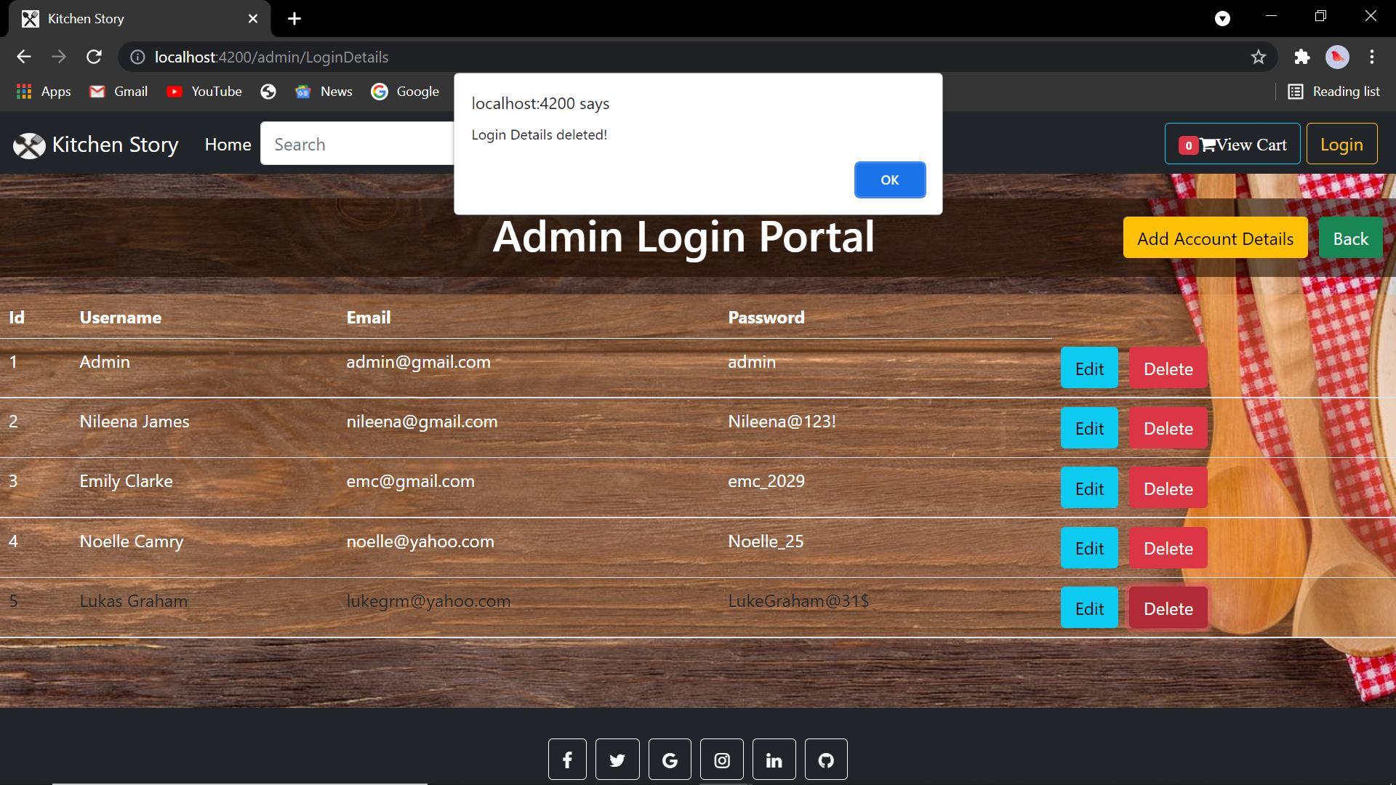 Fig 5.8: Deleting lukas’s account. 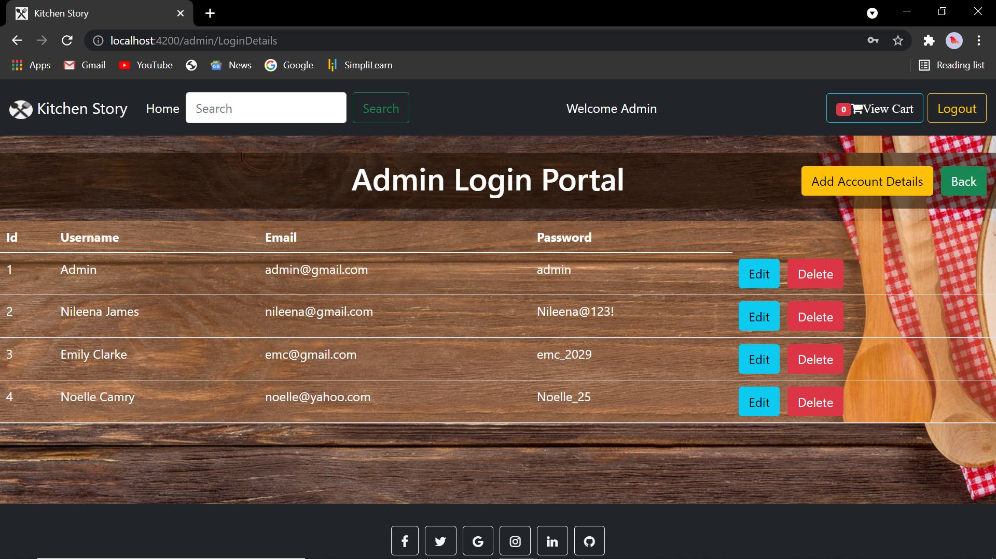 Fig 5.9: Updated table.**

* As seen from **fig 5.2** to **fig 5.9**, the following operations can be performed in the login dashboard:
  + Add Account Details: When the admin clicks on the button, a modal pops up, that takes in the id, Name, email and password. If done correctly, the new account will be added to the json files, and it ll be displayed in the admin dashboard. In the fig, an account under the name “Lukas Graham” is created.
  + When the account is created, by default, two buttons will appear on the right side, “Edit” and “Delete”. Clicking “Edit” will make a modal popup, where the admin can modify any of the details including password, and the changes will be updated in the json file and it’ll be reflected in the dashboard.
  + Now, the user “Lukas Graham” can login to his account with his details as seen in **fig 5.7**.
  + On clicking “delete”, the account will be deleted from both the json as well as the dashboard table.
  + All the details will be added in the ‘users’ object in the db.json file.

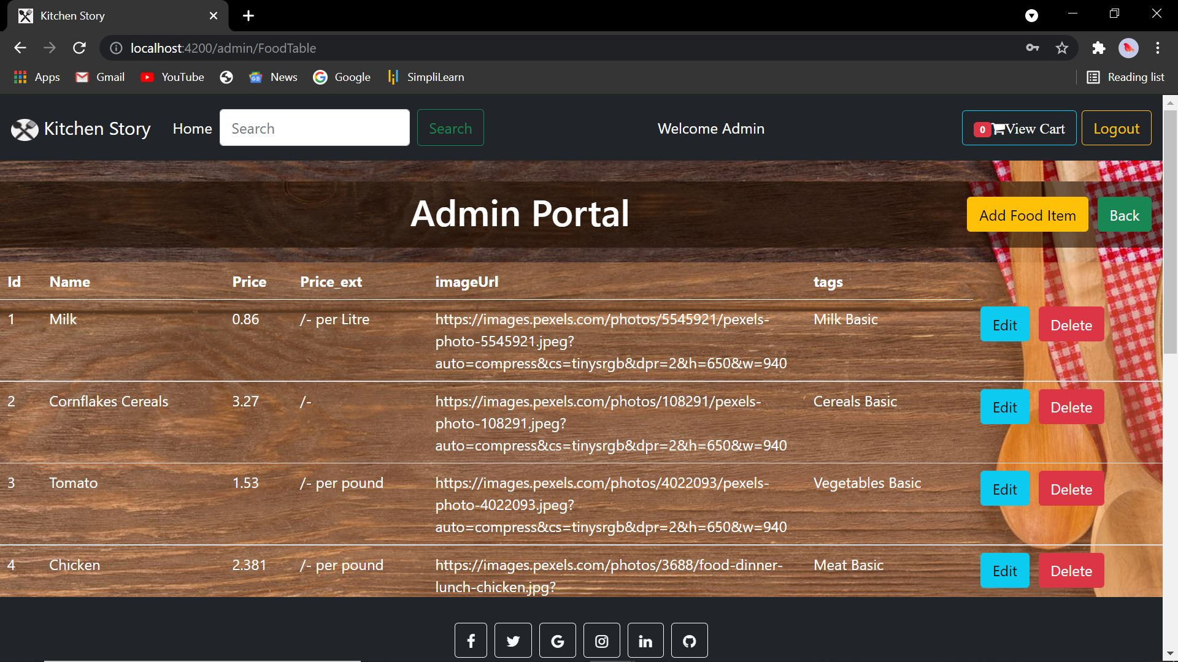 **Fig 5.10: Admin Food Details Dashboard (part 1) 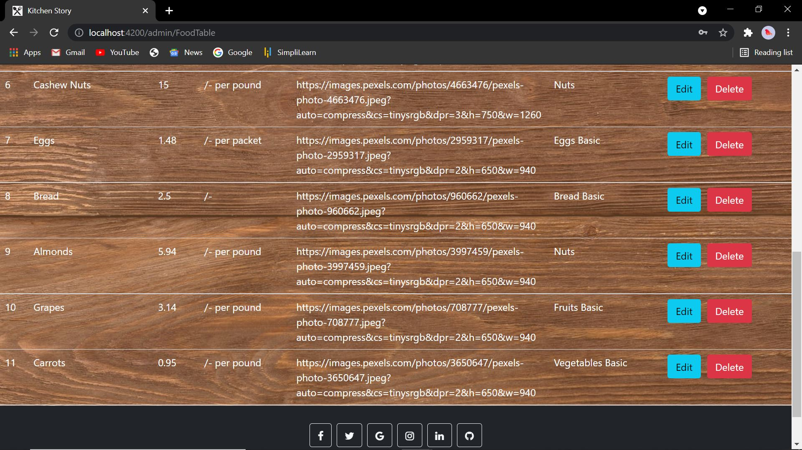 Fig 5.11: Admin Food Details Dashboard (part 2) 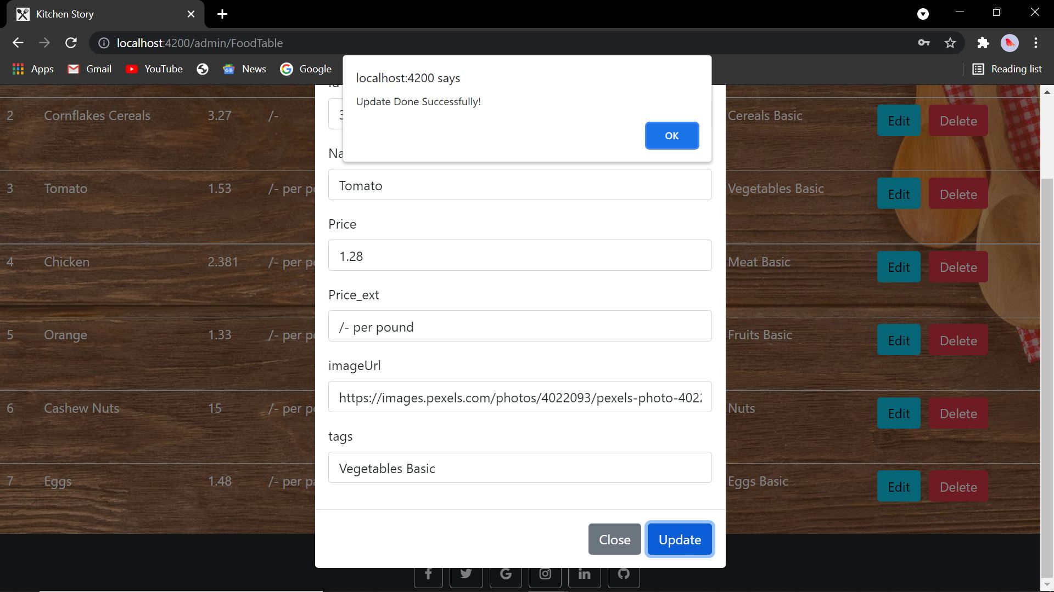 Fig 5.12: Updating the price of tomato. 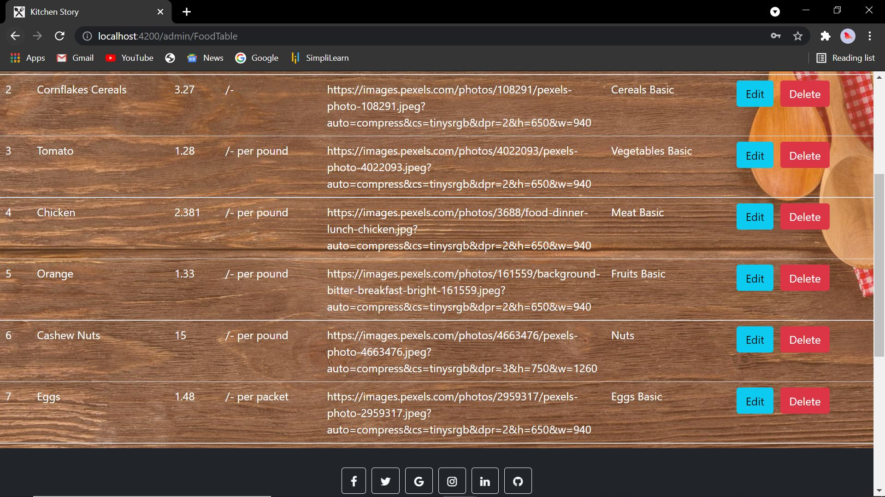 Fig 5.13: Updated table.**

* Clicking on the “back” button will take the admin back to the main page.
* The “Food table” button will take the admin to the Admin portal, that contains the details of the product/food displayed in the **fig 1**.
* As seen in **fig 5.10** to **fig 5.13**, similar to admin login dashboard, the admin can add, edit and delete the product details.
* The new details will be added in the product_details object in the db.json file on performing any of the above-mentioned function.

 **Fig 6: Login through normal user.**

* After successful login, the user will be taken to the homepage as seen in **Fig 1** and **Fig 2**.

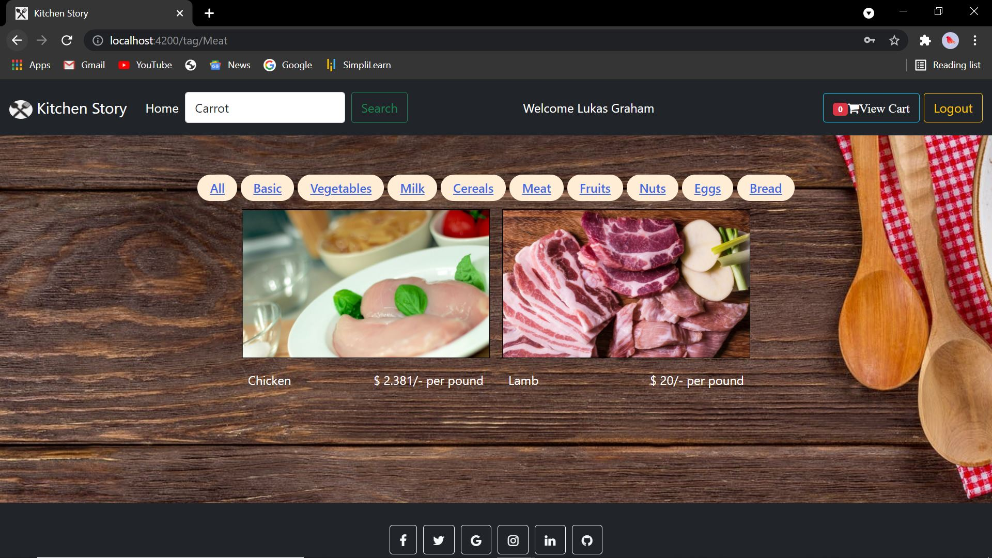 **Fig 6.1: Filter of meat using the 'meat' tag**

* The tags as seen in the above figure, groups the products under a specific tag name.
* So, for the example, I have clicked on the meat tags, and that displayed all the product that comes under the meat section.

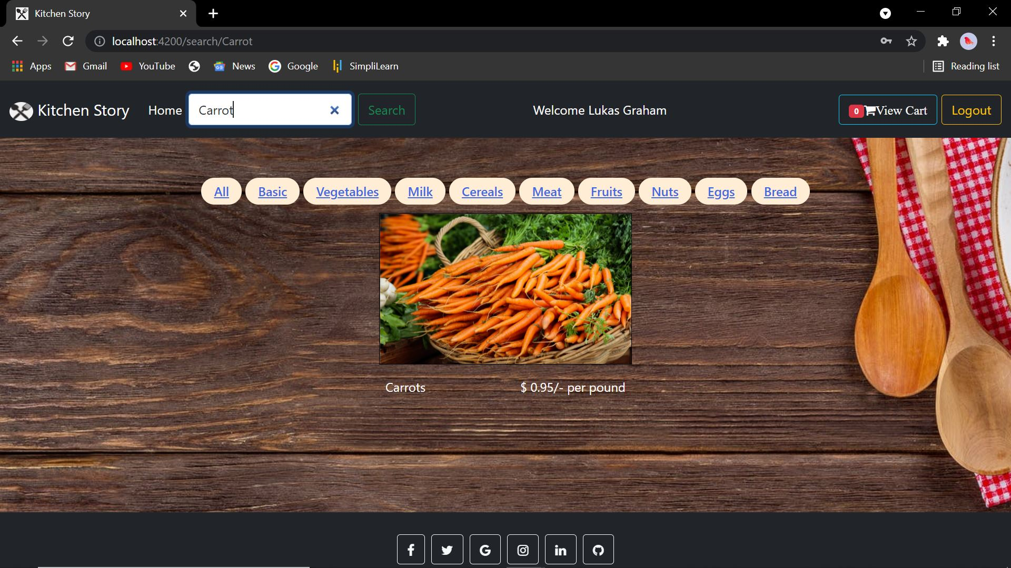 **Fig 6.2: Searching for carrot in the search bar 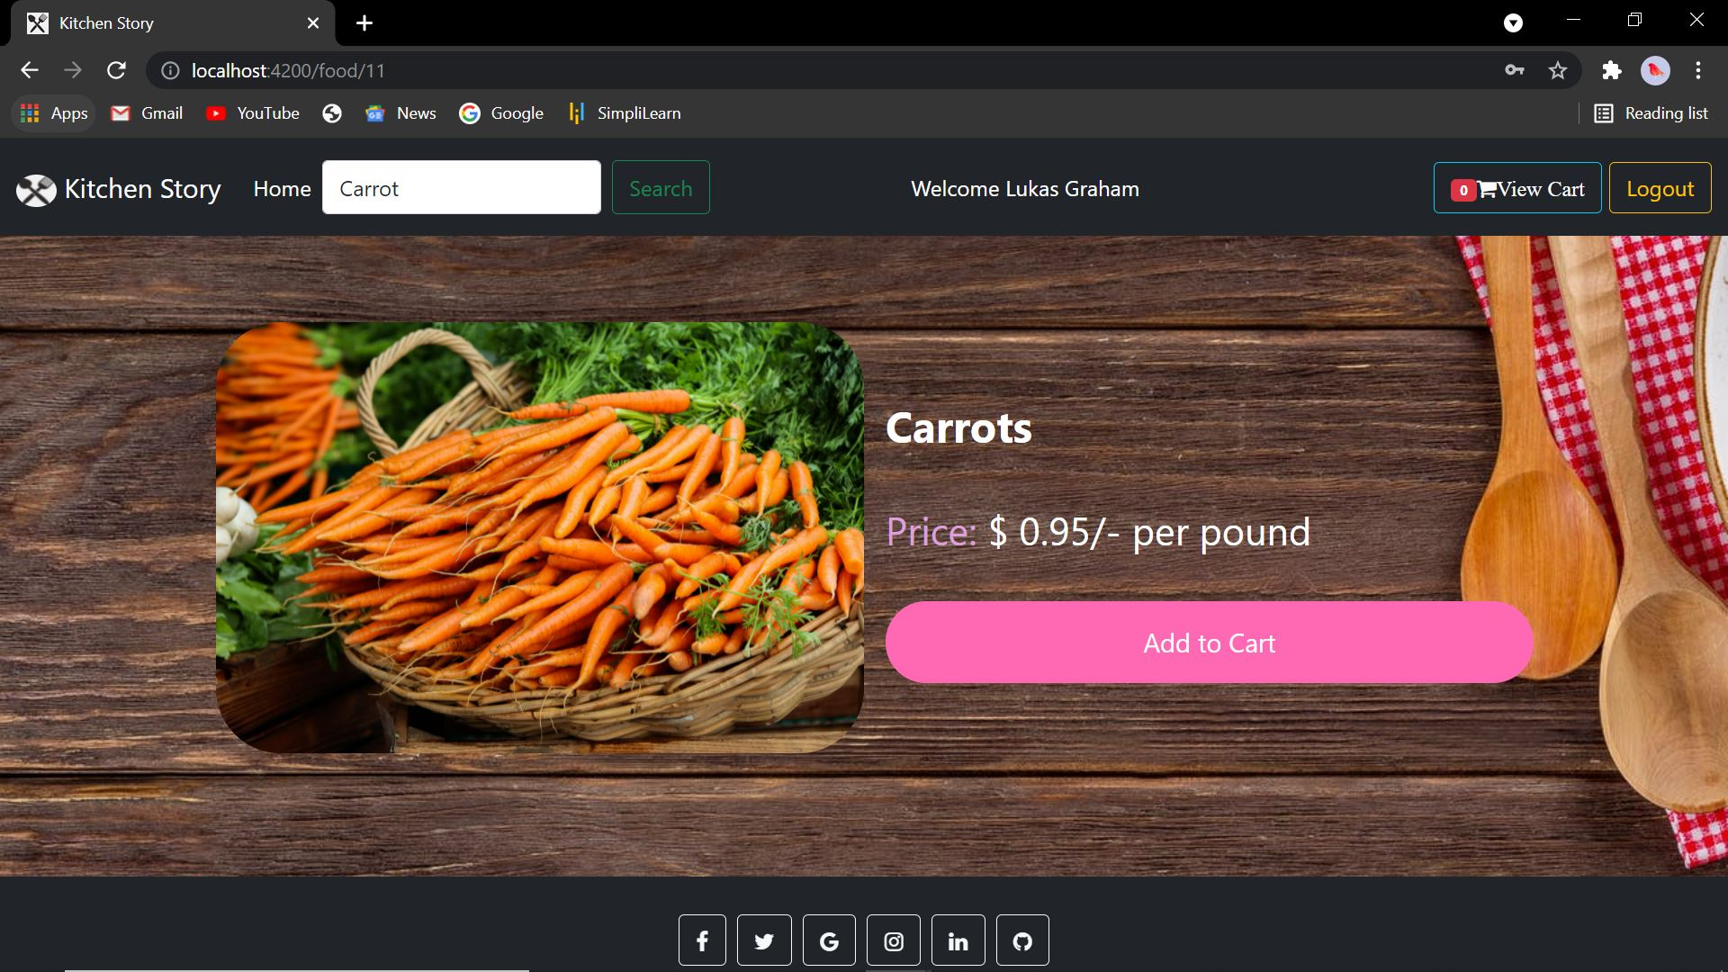Fig 6.3: Adding carrot to cart**

* We can also search for an individual item as seen in the **fig 6.2**, and it’ll display the item if available.
* In the above example, I have searched for ‘carrot’ which is displayed in the body along with the product details.
* When clicked, the user will be directed to the food page, where the user can view the details of the product and can add that item to cart, if they want.

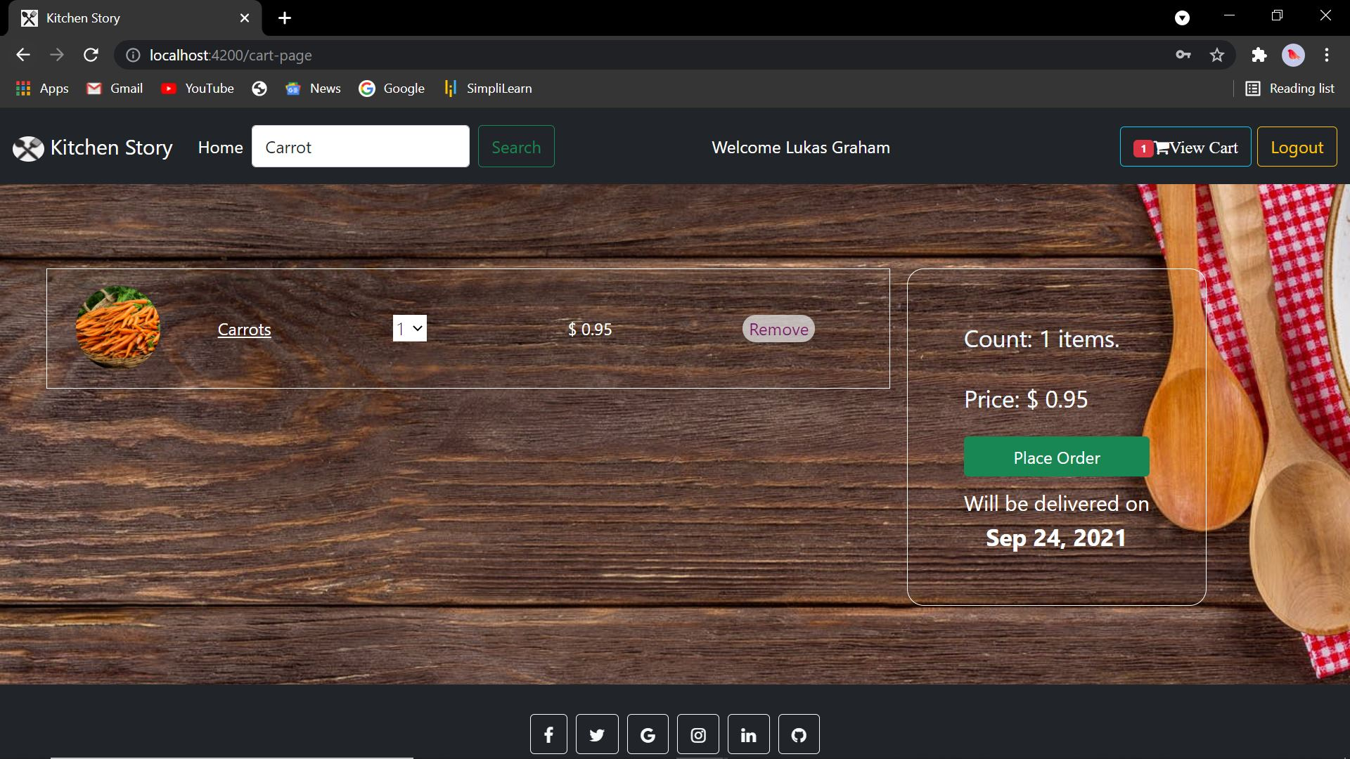 **Fig 6.4: Cart-Page**

* Once the ‘add to cart’ button is clicked, the user will be directed to a cart page.
* This page gives a summary of the items that are added to the cart, the quantity of the items added, the total price of the items added and an option to pay for it.
* The total value will change based on the quantity as well as the number of items added.
* This page can also be viewed by clicking the ‘view-cart’ button in the navbar.
* Also, the delivery date is set by default as two days from the current date.
* All the prices are set in $. The below figure shows the cart-page for multiple items.
* The user can also delete certain items , by clicking on ‘remove’ button.

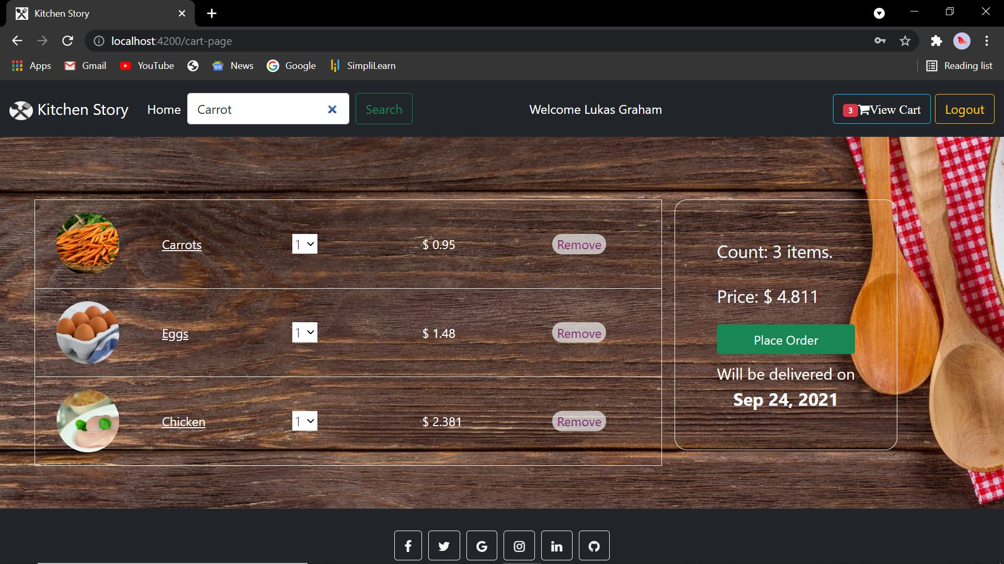 **Fig 6.5: Cart-Page containing multiple items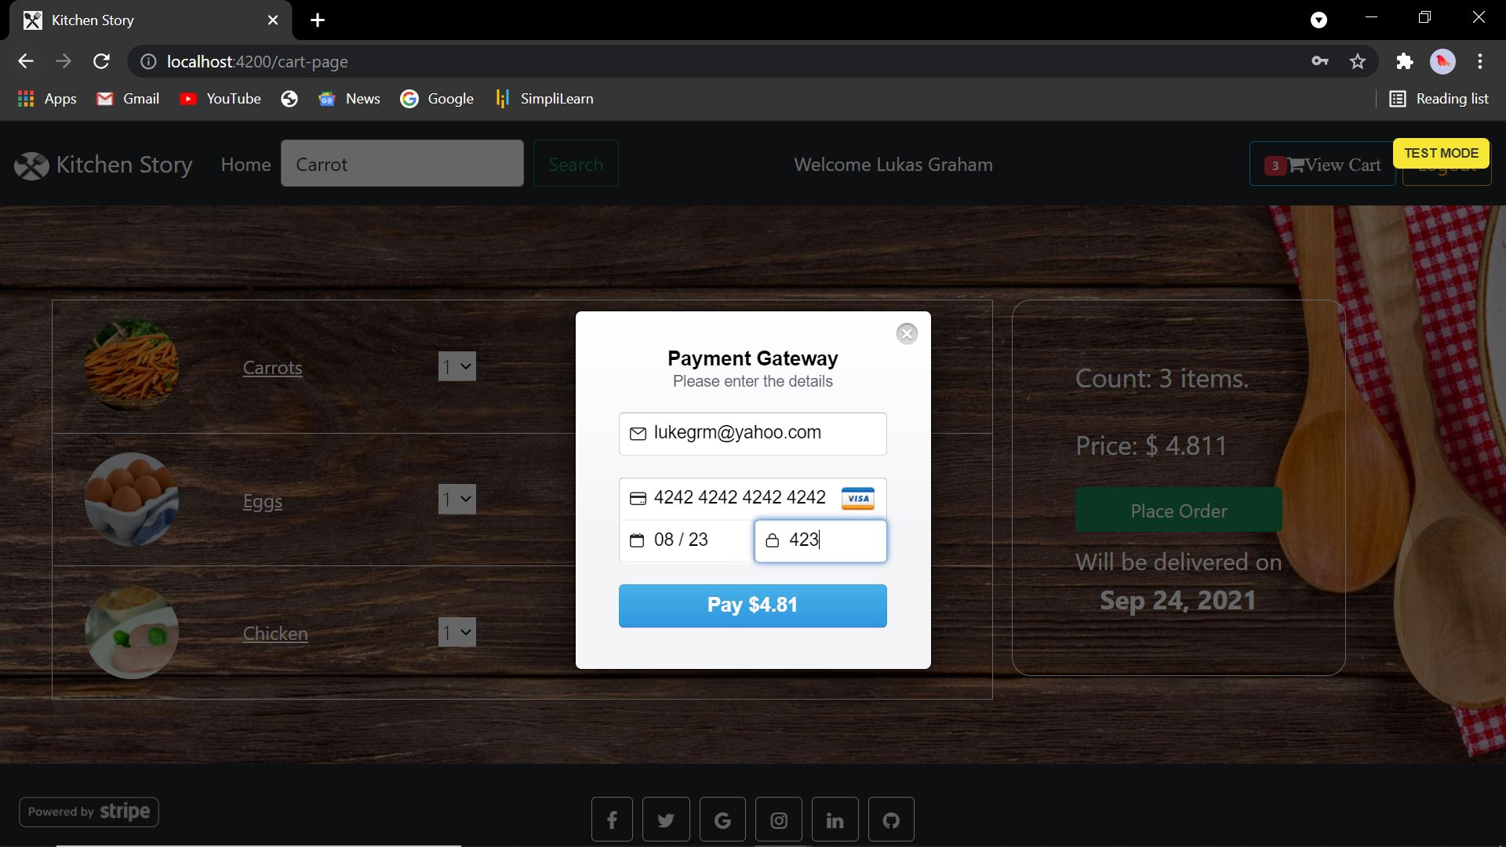Fig 6.6:Payment Gateway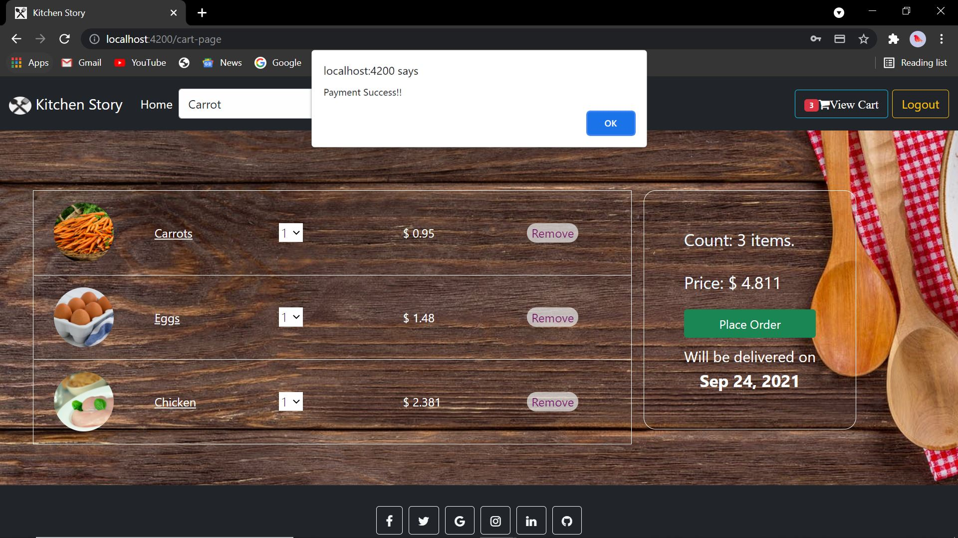 Fig 6.7: On successful payment.**

* On clicking ‘place order’, the user will be directed to a payment gateway page, where the user will have to enter the card details as well as the email.
* On successful payment, a token will be generated and that will be displayed in the console as well as a pop up.
* This token is then used by the backend to do the remaining tasks of transferring the payment.
* **Stripe** is the payment gateway that I have used for integration.
* The payment gateway modal opens up in test mode. All the trials are done in the test mode, using the API key of my account created using my personal id.
* For payment: the card details can be
  + Card no.: 4242 4242 4242 4242
  + Expiry date: 08/23
  + CVV: 423.

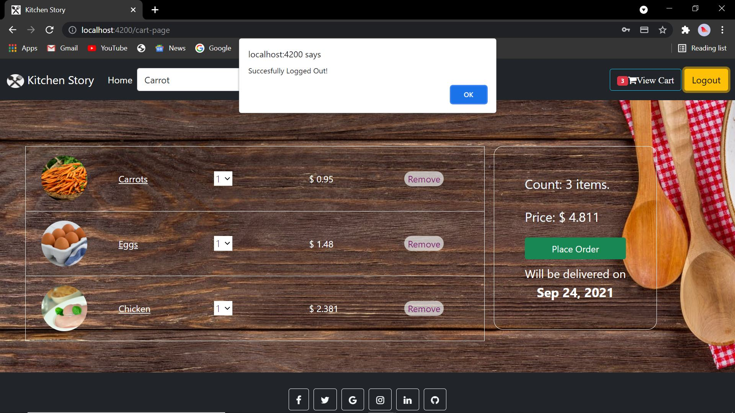 **Fig 6.8: Clicking on logout button.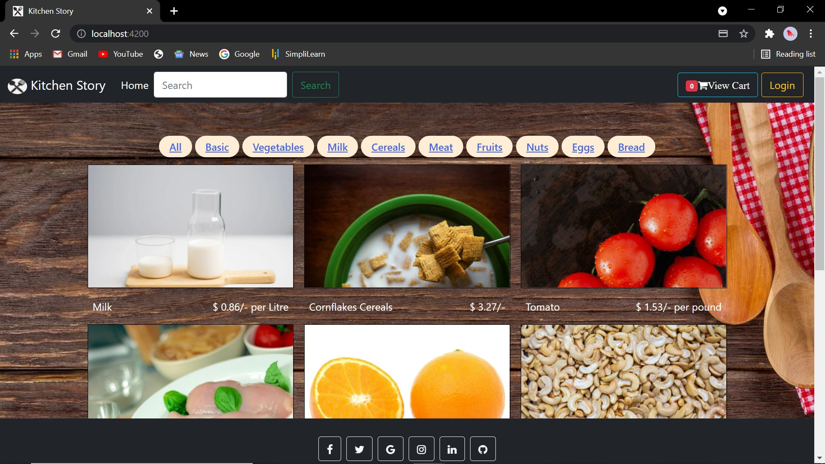 Fig 6.9: After successful logout.**

* On clicking the logout button, the “welcome Lukas graham” disappears and is redirected back to the homepage.
* The logout button turns to login and another user can login.

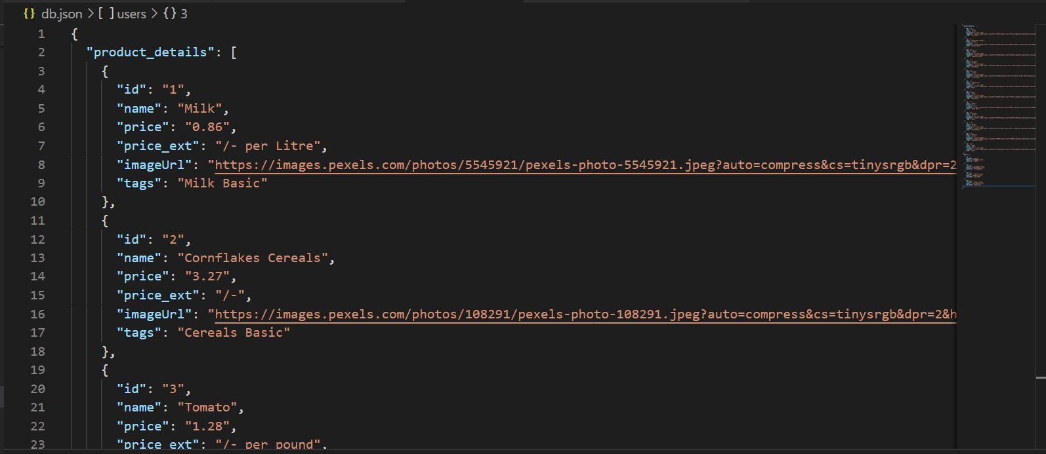 **Fig 7: db.json containing the food details in the product_details object name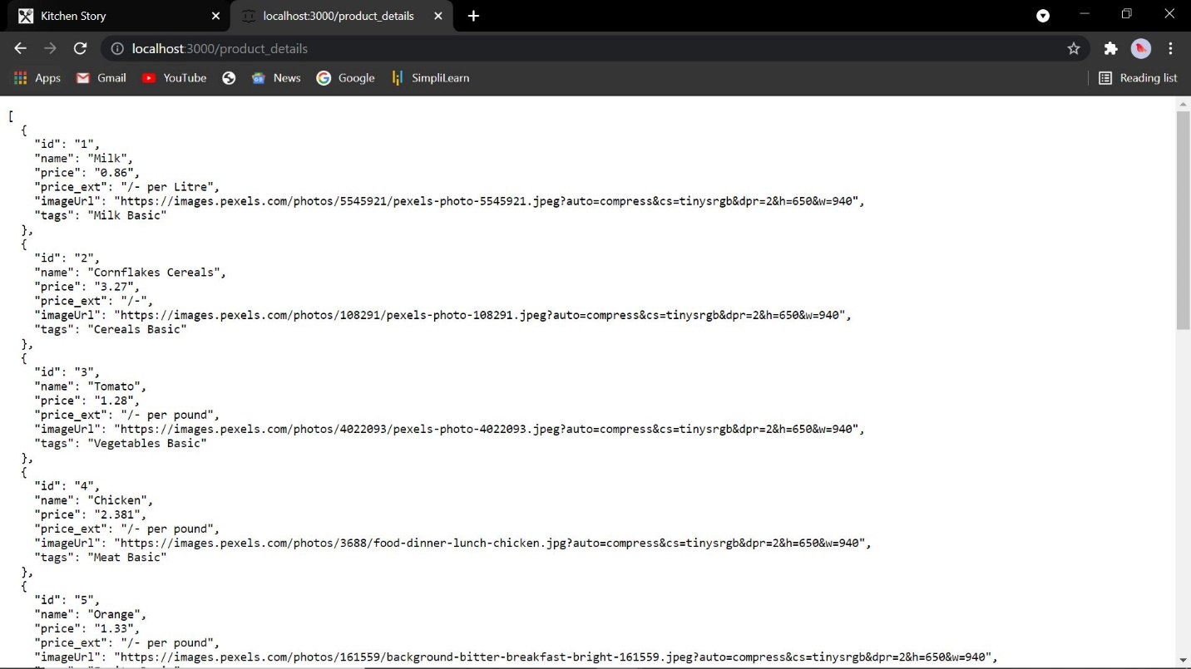 Fig 7.1: product_details running in localhost 3000 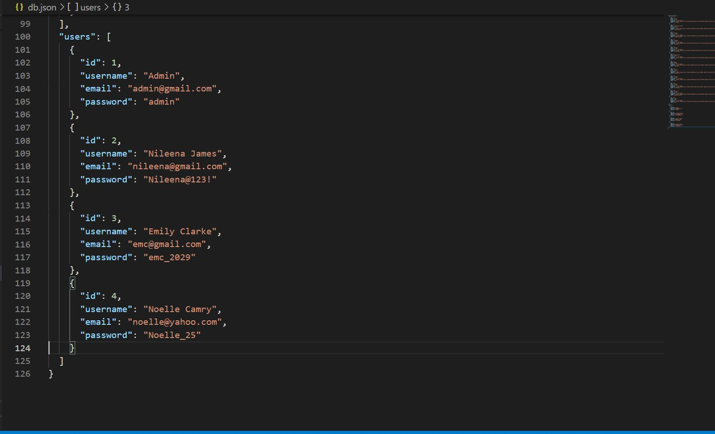 Fig 8: db.json containing the food details in the users object name 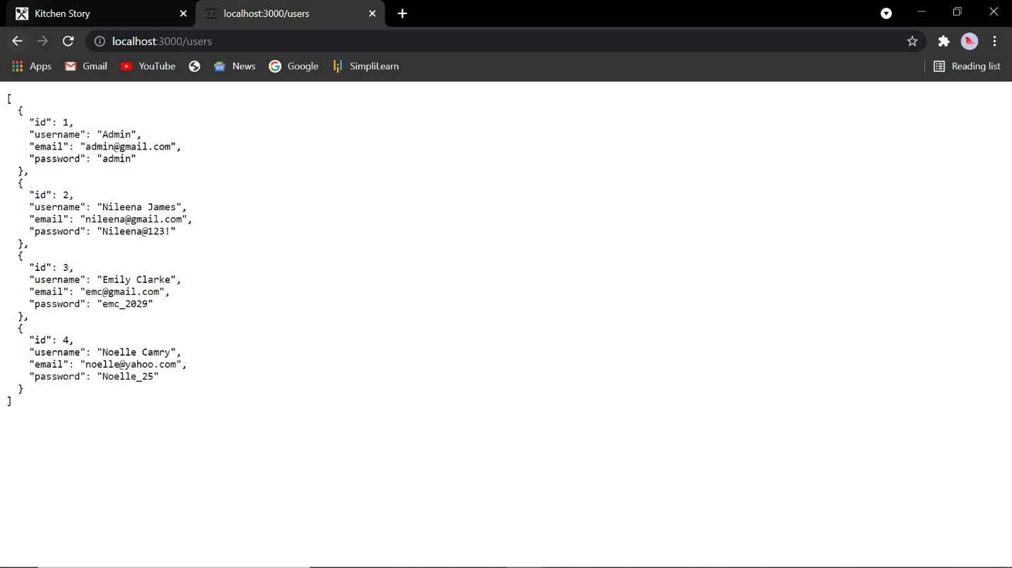 Fig 8.1: users running in localhost 3000**

* The **db.json** file as seen in **fig 7** to **fig 8.1.** Contains two objects “product_details” and “users”.
* The “users” contains details of the accounts, which will then be displayed in an admin dashboard. The account details includes id, username ,email and password.
* The “product_details” contains details of the product displayed in the home page such as name, price, etc.
* The db.json file is run in localhost:3000 with the help of command “json-server –watch db.json” in the terminal, where the updates are notified and the changes are made in the required place.

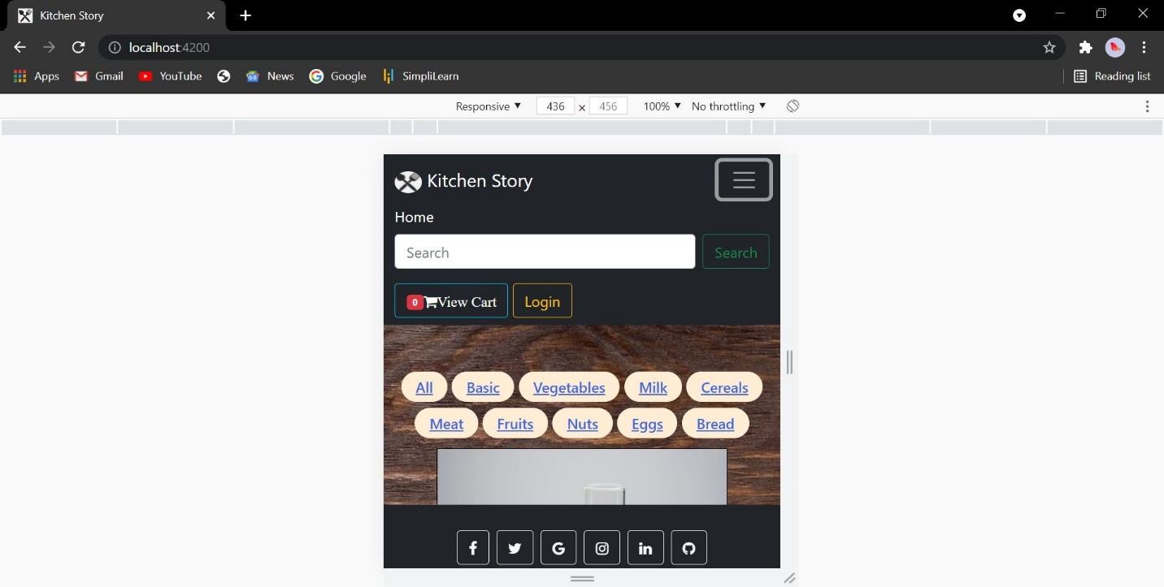**Fig 9: Responsive view of the site (part-1).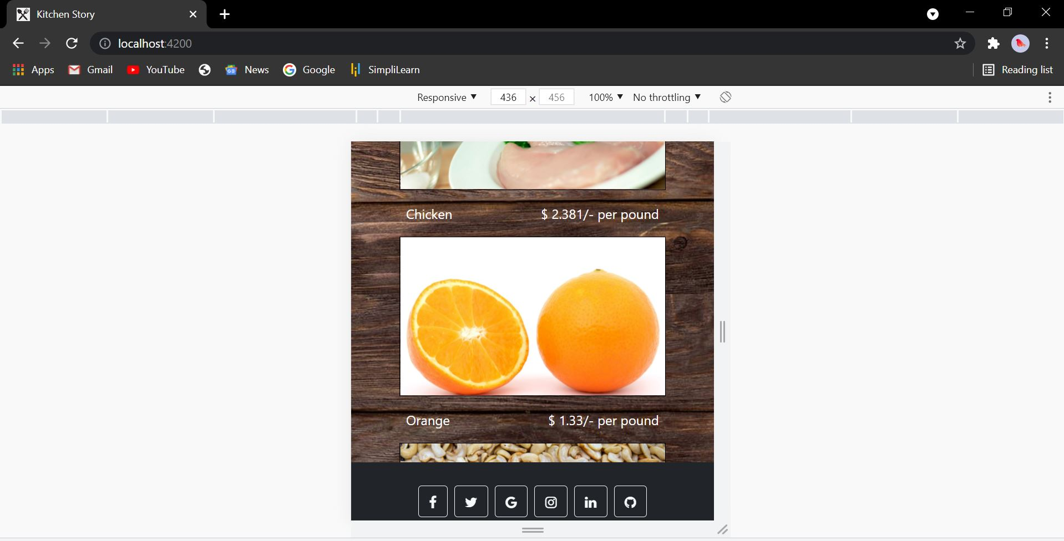 Fig 9.1: Responsive view of the site (part-2).**

* Fig 9 and Fig 9.1 shows how the site will look in responsive view of width and height of 436px and 456px.
* The responsiveness is taken into consideration for some of the features with the help of bootstrap.

**Thank you!**

**Name: Nileena James.**